A Meta-analysis of the Survival Processing Advantage in Memory

John E. Scofield, Erin M. Buchanan, and Bogdan Kostic

Missouri State University

Author Note

John E. Scofield, Department of Psychology, Missouri State University; Erin M. Buchanan, Department of Psychology, Missouri State University; Bogdan Kostic, Department of Psychology, Missouri State University

Correspondence should be addressed to John E. Scofield, Department of Psychology, Missouri State University, 901 S. National Ave., Springfield, MO 65897. (417) 836-5000.

E-mail: John1551@live.missouristate.edu

Abstract

The survival processing advantage occurs when processing words for their survival value improves later performance on a memory test. Due to the interest in this topic, we conducted a meta-analysis to review literature regarding the survival processing advantage to estimate a bias-corrected effect size. Traditional meta-analytic methods were used, as well as the Test of Excessive Success, *p*-curve, *p*-uniform, trim and fill, PET-PEESE, and selection models to re-evaluate effect sizes while controlling for forms of small-study effects. Average effect sizes for survival processing ranged between *ηp2* = .06 and .09 for between-subjects experiments, and between .15 and .18 for within-subjects experiments after correcting for potential bias and selective reporting. Overall, researchers can expect to find medium to large survival processing effects, with selective reporting and bias correcting techniques typically estimating lower effects than traditional meta-analytic techniques.

*Keywords:* Survival processing, meta-analysis, memory, effect size

A Meta-analysis of the Survival Processing Advantage in Memory

Evolutionary psychologists view ancestral environments as an integral part of evolutionary psychology. They place importance on this aspect and posit that our brains contain adaptations in the form of modules. These modules help solve adaptive problems that were present in our ancestral environments (Cosmides & Tooby, 1994; Tooby & Cosmides, 2005). Nairne and Pandeirada (2008) argue that memory is adapted to remember information that is specifically relevant to our evolutionary fitness. That is, our memory systems have evolved around the presence of survival contexts. Studies spanning back to 2007 have shown that processing words for survival value improved later performance on a memory test, and that this memory has significant adaptive value (Nairne, Thompson, & Pandeirada, 2007).

In a typical survival-processing paradigm, participants imagine they are stranded in a grasslands environment without any survival materials and are susceptible to predation and other potential dangers. Participants view and rate a list of words based on how relevant each item would be in that survival scenario. Following the rating procedure, participants receive a memory test and write down as many items as they can recall from the list they previously viewed (Nairne, Pandeirada, & Thompson, 2008). Different encoding instructions can be implemented for comparison, where participants might imagine themselves in a scenario involving moving to a new country, a neutral processing task such as rating for pleasantness, or other possible scenarios that vary in their degree of evolutionary relevance. Results typically show that the survival scenario leads to an advantage in memory compared to other types of encoding procedures. For instance, Renkewitz and Müller (2015) successfully replicated Nairne et al. as a part of the Reproducibility Project (Nosek et al., 2015). By employing similar methods, Renkewitz and Müller showed that words rated for their survival relevance were recalled at a greater rate than a vacation scenario. This survival processing advantage has also been replicated with different comparison conditions, stimulus materials, encoding scenarios, and populations. Survival processing has been shown to persist across different types of designs as well as with recall and recognition tests (Aslan & Bauml, 2012; Bell, Röer, & Buchner, 2013; Kostic, McFarlan, & Cleary, 2012; Nairne & Pandeirada, 2010; Otgaar, Smeets, & van Bergen, 2010; Röer, Bell, & Buchner, 2013; Weinstein, Bugg, & Roediger, 2008).

Nairne et al. (2007) describes a functional-evolutionary perspective (also known as an ultimate explanation) as their theoretical basis regarding the memorability of survival relevant items. From this perspective, memory systems have evolved to remember items and information relevant to survival, and that processing in terms of their relation to survival improves retention (Burns, Hwang, & Burns, 2011; Nairne et al., 2008). The survival processing advantage has also been examined from a structuralist or proximate approach, which focuses on the relevant mechanism and explanation of a phenomenon (Burns et al.; Butler, Kang, & Roediger, 2009; Howe & Derbish, 2010; Kang, McDermott, & Cohen, 2008; Kroneisen & Erdfelder, 2011; Soderstrom & McCabe, 2011). Some researchers using this approach have proposed that general principles of memory can explain the survival processing advantage without any need to involve fitness-relevance (Howe & Otgaar, 2013).

Kostic et al. (2012) and Soderstrom and McCabe (2011) provided evidence that survival processing effects do not uniformly require ancestral survival scenarios as a pre-requisite, as this effect was extended across different settings that were not relevant to evolution. Kroneisen and Erdfelder (2011) hold the position that survival processing can be traced back to and explained by richness of encoding factors. This richness of encoding allows for elaborate and distinctive encoding more than control tasks or scenarios, which can explain the increase in retention. Consistent with the richness of encoding, participants generate more uses for items in survival scenarios. When the possibility to spontaneously generate ideas is limited from differing contexts, the survival processing advantage disappears (Kroneisen & Erdfelder, 2011; Kroneisen, Erdfelder, & Buchner, 2013; Röer et al., 2013).

The role of emotions in survival processing remains uncertain. Kang et al. (2008) compared survival scenarios to a bank heist scenario to examine whether arousal could account for the survival processing advantage. Word recall was better in the survival condition than in the bank heist condition, albeit both scenarios received similar excitement/emotional ratings. Smeets, Otgaar, Raymaekers, Peters, and Merckelbach (2012) proposed that survival-processing scenarios could possibly induce stress, which could improve memory from stress hormone effects. However, the effects of stress on memory were found to be independent of the survival processing effect. Soderstrom and McCabe (2011) also examined the influence of emotions by having participants imagine having to protect themselves against zombies. Even though arousal and valence ratings were higher in this zombie condition than the original grasslands scenario, they were not significant covariates and could not account for the recall differences.

Thinking about death and the effects of mortality salience on memory has been proposed to explain the survival processing advantage. Burns, Hart, Kramer, and Burns (2014) considered the “dying-to-remember” (DTR) effect, where participants are placed in a mortality salient state, and tested if the DTR effect was related to survival processing. Burns et al. found an association with the DTR effect and an increase in item-specific processing. These results posit that the mechanisms at hand for survival processing and DTR effects share a relationship and overlap. However, Bell et al. (2013) found that the survival processing advantage was not due to negativity or mortality salience.

False memory is another area investigated within the survival processing advantage. Survival-related words were found to be more susceptible than neutral words to false memory effects, and processing survival-related words in terms of their relevance to survival increased susceptibility to false memory (Howe & Derbish, 2010). Even though survival-related information including false memories resulted in worse, not better memory, it still could have adaptive significance, for instance with false memories making better primes for problem solving (Garner & Howe, 2014; Howe & Derbish, 2010).

Overall, while there are many successful replications of the survival processing advantage in memory, research on survival processing provides inconclusive evidence on the explanation behind the phenomenon. Work has examined both the ultimate and proximate explanations behind survival processing. For instance, Burns et al. (2011) proposed that survival processing fosters both relational and item-specific processing for encoding, superior to control strategies. Broder and Kruger (2011), however, report that functional analysis in the case of survival processing is inconclusive. An adaptive memory, Broder and Kruger point out, should not only include item memory, but also aspects including source memory should be enhanced for its survival value, but they did not find any effects of adaptive source memory. Nairne and Pandeirada (2010) concurred and did not find survival advantages for source memory. The survival processing advantage also vanished under dual task conditions, implying that survival processing may not be prioritized in dual task contexts (Kroneisen, Rummel, & Erdfelder, 2014). McBride, Thomas, and Zimmerman (2013) also point out that if memory serves adaptive needs, it might have evolved in an older form of memory. However, McBride et al. found no support for a survival advantage in implicit tests. In sum, although the functional-evolutionary approach of survival processing has certainly received support, work is still ongoing.

Meta-analyses provide us with an alternative to the normal, narrative discussions of research studies, which is useful in attempting to make sense of precipitately expanding research (Glass, 1976; Wolf, 1986). The purpose of this meta-analysis was to review the literature regarding the survival processing advantage, and to aggregate the available data to show an averaged effect of the survival processing advantage. Effect sizes differ for various reasons, potentially as a result of different random sampling (Francis, 2012). Therefore, effect sizes are better understood pooled together across studies. This paper served to address the aggregation of available studies by performing a literature search, assessing homogeneity of the effect size parameters, pooling effect sizes, testing and correcting for potential forms of bias, and determining whether any characteristics of these studies were systematically related to the effect size (Borenstein, 2009; Dunlap, Cortina, Vaslow, & Burke, 1996; Hedges, 1982; Hedges & Olkin, 1985; Morris & DeShon, 2002).

**Method**

**Data Collection**

All materials, including datasets and *R* code are available online at http://osf.io/6sd8e. A literature search was conducted to identify articles related to a survival processing advantage utilizing search engines and a manual reference check. Search terms for the literature search included memory, adaptive memory, survival processing, and evolution. We first conducted searches on PsycINFO and Google Scholar to locate articles on the survival processing advantage, and then manually retrieved sources cited within each individual study. Other mediums, such as psychfiledrawer.org and PsyArXiv pre-prints were also used to search for articles. The dependent variable of interest was word recall from differing types of encoding strategies. Overall, these searches returned 49 relevant studies comprised of 113 experiments, which included seven unpublished dissertations and theses. Ninety experiments were acceptable for inclusion in this analysis. Twenty-three experiments were excluded from this analysis for insufficient quantitative information or differing measures of interest. A table of specific experiments with exclusion explanations can be found at http://osf.io/6sd8e. 54.4% (49) of initially included experiments utilized a between-subjects design and 45.6% (41) utilized a within-subjects design. All experiments included in the analysis were published between 2007-2015.

**Effect Size, Variance, and Confidence Interval Calculations**

Test statistics were extracted from all experiments. Only main effects of survival processing condition were considered. No test statistics were pulled from interactions or main effects unrelated to processing condition. A table of experiment characteristics including each experiment’s author, year the study was published, research design, effect size, and sample size is available online at http://osf.io/6sd8e.The majority of experiments (90%, 81) used ANOVA analyses to assess their hypotheses, and therefore, we used partial eta squared as our measure of effect size. Only one effect size was used from each specific experiment; thus, all effect sizes were independent. If a study contained multiple experiments, only the main effect of survival processing from each experiment was calculated. Regardless if effect sizes were reported in original articles, these values were re-calculated from *F*-ratio and *df* statistics presented for each experiment with equation 1 provided by Cohen (1965) of:

$$\begin{aligned}η_{p}^{2}=\frac{F × {df}_{effect}}{F {× df}_{effect}+{df}_{error}}\#\left(1\right)\end{aligned}$$

All effect sizes were treated as partial eta squared, because, with one-way between-subjects ANOVA designs, full and partial eta values are the same. In one-way within-subjects designs, full eta squared would traditionally be calculated by using the sum of squares total (i.e. sum of squares model + sum of squares subject + sum of squares residual) as the denominator. However, most software packages calculate partial eta squared by excluding the sum of squares subject variance, and thus, we assumed values reported in primary studies were partial eta squared. Eight experiments used *t*-tests, and therefore, Cohen’s *d* was reported. For experiments utilizing *t-*tests, Cohen’s *d* values were first converted into correlation coefficients with equation 2, provided by Cooper, Hedges, and Valentine (2009):

$$\begin{aligned}r=\frac{d}{\sqrt{d^{2}+a}} \#\left(2\right)\end{aligned}$$

where *a* is a correction factor[1] when n1 ≠ n2. This conversion is based on a design with two-independent means. An adequate formula has not currently been derived for transforming Cohen’s *d* values based on a within-subjects design. While only six of the 90 experiments reported Cohen’s *d* using a within-subjects design, the use of this formula may have caused biased transformations of those effect sizes. Correlation coefficients were then converted into partial eta squared with equation 3:

$$\begin{aligned}η_{p}^{2}=r^{2} \#\left(3\right)\end{aligned}$$

We followed traditional meta-analytic procedures, detailed in Cooper et al. (2009). Primary effect sizes were weighted in terms of their inverse variance (Sanchez-Meca & Marin-Martinez, 2008). Confidence intervals were also calculated for every meta-analytic effect size reported in the current project. To estimate sampling variance of partial eta squared, primary effect sizes were first converted to raw correlation coefficients. This procedure was advantageous because of the dearth of literature indicating how to estimate variance for eta type measures, which is a crucial component to the techniques chosen here. Borenstein (2009) advises against analyses performed using correlation coefficients because the variances are themselves dependent on the correlation, and that raw correlations are not normally distributed like coefficients transformed to Fisher’s *z* scale. To circumvent this problem, correlation coefficients were converted to the Fisher’s *z* scale via equation 4:

$$\begin{aligned}z=0.5 ×\ln\left(\frac{1+r}{1-r}\right) \#\left(4\right)\end{aligned}$$

The variance of *z* could then be estimated per equation 5:

$$\begin{aligned}V_{z}=\frac{1}{n-3} \#\left(5\right)\end{aligned}$$

wherein standard error was the square root of that variance estimation. Traditional meta-analytic procedures were then followed using *z*. Both fixed and random effects models were reported, pooling primary effect sizes across all experiments (Hedges & Olkin, 1985; Hedges & Vevea, 1998; Marin-Martinez & Sanchez-Meca, 2010; Sanchez-Meca & Marin-Martinez, 2008). However, considering that pooling primary effect sizes across different research designs may not be appropriate, separating experiments according to research design served to make groups more homogeneous. Primary effect sizes were binned into subgroups (between-subjects or within-subjects design). Primary effect sizes for the fixed effects model were weighted in terms of their inverse variance,

$$\begin{aligned}w_{i}^{FE}=\frac{1}{V_{z}}\#\left(6\right)\end{aligned}$$

and then pooled across experiments, according to that weight. For the random effects model, primary effect sizes were again weighted in terms of their inverse variance, this time using the summation of an experiment’s within and between study variance,

$$\begin{aligned}w_{i}^{RE}=\frac{1}{V_{z}+ τ^{2}}\#\left(7\right)\end{aligned}$$

where $τ^{2}$ refers to the between study variance. Between study variance was estimated using the Paule-Mandel estimator (Langan, Higgins, & Simmonds, 2016; Veroniki et al., 2016). After meta-analytic analyses were performed, the meta-analytic effect size *z* was converted back into partial eta squared for presentation with equation 8:

$\begin{aligned}n_{p}^{2}={\left(\frac{e^{2z}-1}{e^{2z}+1}\right)}^{2}\#\left(8\right)\end{aligned}$

Confidence intervals for both primary and meta-analytic effect sizes were calculated on normal distribution calculations with the *metafor* package (Viechtbauer, 2010), and all analyses in this paper are based on normal distribution confidence intervals. However, recent literature on effect sizes indicates that non-central confidence intervals are potentially more appropriate (Cumming, 2012; Kelley, 2007; Smithson, 2003), and therefore, these non-central *F* distribution estimates can be found in the supplementary online material for comparison. Forest plots are presented in Figures 1 and 2 for graphical representation of primary and meta-analytic effects, with confidence intervals. Forest plots show each study’s primary effect size, with each box’s size corresponding to the weight of each study, and horizontal lines indicating the confidence interval for each individual effect size. Considering the large number of experiments, experiments were plotted and separated by research design (between-subjects and within-subjects).

**Outlier and Influential Study Detection**

Before reporting meta-analytic effect sizes, outliers and influential cases were assessed using the *metafor* package by calculating studentized deleted residuals, DFBETAS values, and the ratio of generalized variances (COVRATIO, Viechtbauer & Cheung, 2010). Studentized deleted residuals, an outlier identification technique, compares observed effect size values with models excluding each respective study. Testing for influence, in addition to testing for outliers, is important because the presence of an outlying experiment may not necessarily change, or influence, specific conclusions. An experiment is deemed influential if excluding that respective experiment yields changes in the fitted model (Viechtbauer & Cheung, 2010). DFBETAS and generalized variance ratio techniques both indicate influential experiments. DFBETAS values indicate the overall change in effect size after excluding each respective experiment from initial model fitting. DFBETAS values exceeding one indicate influential experiments. COVRATIO values smaller than one suggest that the exclusion of the *i*th experiment yields more precision in model coefficient estimates (Viechtbauer & Cheung, 2010). Outliers/influential cases were tested using both a random effects and fixed effects model, and three common outliers/influential cases between the two types of models were identified (a table of specific identified outliers is available in the online supplemental material).

By definition, however, studies acceptable for inclusion in a meta-analysis may not be considered outliers. Further, Viechtbauer and Cheung (2010) note that the detection of an outlying/influential study does not automatically merit its deletion. Therefore, a sensitivity analysis was conducted with models both including and excluding those outlying/influential cases. The sensitivity analysis (available in the online supplementary materials) revealed that the main results and conclusions remain the same whether those cases were included or excluded. All subsequent analyses, knowing that main results/conclusions remain the same, excluded these specific cases to reduce the amount of heterogeneity to acceptable levels for bias-correcting techniques. $τ^{2}$ was estimated to be 0.02 including detected cases, whereas excluding those three identified cases yielded $τ^{2}$ of 0.01. The change in $τ^{2}$ (52.1%, see Viechtbauer & Cheung, 2010 for details) suggested that the exclusion of these influential cases decreased estimates of heterogeneity. The exclusion of outlying/influential cases for the current meta-analysis was also advantageous, considering high heterogeneity estimates can be problematic with analyses such as *p*-curve, *p*-uniform, trim and fill methods, and selection models. High heterogeneity limitations are addressed in the heterogeneity results and discussion section of the manuscript.

**Results**

Traditional fixed effects and random effects meta-analyses, with outliers/influential cases excluded, revealed overall meta-analytic effect size estimates of *ηp 2* = .11, 95% CI [.10, .12] and *ηp 2*= .12, 95% CI [.10, .14], respectively. However, a comparison of primary effect sizes across different research designs revealed that effect sizes from experiments using within-subjects designs had higher effect sizes than experiments using between-subjects designs, Welch corrected *t*(67.68) = -3.46, *p* < .001, *d* = 0.73, *BF*10 = 49.02. Bayes factors were calculated with the *BayesFactor* package (Morey & Rouder, 2015), with a standard Cauchy prior and *rscale* = 1. We created homogeneous subgroups based on the type of research design and fitted meta-analytic models separately. Alternatively, a single model could be fitted using type of research design as a categorical moderating variable. Both of these options are viable; however, Viechtbauer (2010) recommends fitting models separately due to differences in primary effect size and heterogeneity estimates across levels of a categorical variable, which was the case across the type of research design. Considering between-subjects experiments, traditional fixed and random effects meta-analyses revealed overall meta-analytic effect size estimates of *ηp 2* = .09, 95% CI [.07, .10] and *ηp 2* = .09, 95% CI [.07, .11], respectively. Fixed and random effects meta-analyses for within-subjects designs showed overall meta-analytic effect size estimates of *ηp 2* = .17, 95% CI [.15, .20] and *ηp 2* = .17, 95% CI [.14, .21]. The forest plot for between-subjects designs is presented in Figure 1 and within-subjects designs in Figure 2. Table 1 shows fixed and random effects model estimates for overall, between, and within-subjects designs across all results described below.

**Homogeneity**

Homogeneity of the meta-analytic results was assessed using the *Q*-statisticwith a chi-square distribution (*k* – 1 *df*), wherein *k* was the number of studies (Cochran, 1954; Huedo-Medina, Sanchez-Meca, & Marin-Martinez, 2006), and the *I­2* index. The *Q*-statistic is akin to variance of the effects, as a between study weighted sum of squared differences, which indicates the variation between study effects. *I2* is similar to the *Q*-statistic, which quantifies the degree of heterogeneity versus chance in a meta-analysis, and therefore, both values were reported. *I2* is often considered to measure the inconsistency between studies (Higgins, Thompson, Deeks, & Altman, 2003)*.* However, *I2* estimates can be inexact with a small number of experiments in a meta-analysis or if sample size within experiments is small. Wide confidence intervals can be understood as a manifestation of these inexact estimates, which are related to power issues found with the *Q*-test. Therefore, 95% confidence intervals were reported along with every *I2* statistic.Reasons why tests could fail homogeneity include the use of different measures, designs, or even because the sampling of subjects differed greatly (Huedo-Medina et al., 2006; Wolf, 1986). These values were calculated using the *meta* package.

We rejected this homogeneity assumption for overall effects, *Q*(86) = 175.04, *p* < .001. The amount of variability among effect sizes caused by true heterogeneity across experiments was *I2* = 50.9%, 95% CI [37.1%, 61.6%]. We then assessed homogeneity for between-subjects design experiments, *Q*(47) = 75.25, *p* = .01. According to the *I2* index, heterogeneity was reduced to a low-moderate level, when split by research design, *I2* = 37.5%, 95% CI [11.2%, 56.1%]. For experiments implementing a within-subjects design, homogeneity was rejected, *Q*(38) = 69.67, *p* < .01. The *I2* index, however, indicated a moderate level of heterogeneity, *I2* = 45.5%, 95% CI [20.4%, 62.6%]. Excluding outlying/influential cases and breaking experiments into homogeneous subgroups helped to decrease heterogeneity, thus making the use of bias-correcting techniques appropriate.

**Test of Excessive Success**

The Test for Excessive Success (TES; Ioannidis & Trikanilos, 2007) was used to determine the likelihood of rejecting the null hypothesis given a specific number of experiments. The logic of the TES is similar to hypothesis testing, in the sense that the null hypothesis in the TES is that experiments were run properly and without bias. The use of the TES is appropriate for individual studies with four or more experiments (Francis, 2012, 2014). Statistical power for each experiment included in the TES analysis was calculated (with the *pwr* package, Champley, 2009) using the meta-analytic effect size estimate, according to which research design was implemented. For example, if survival processing was manipulated between-subjects in an experiment, power was calculated using the traditional between-subjects meta-analytic effect size, not that primary study’s effect size. Francis (2012, 2014) details this procedure, indicating that if the product of all the experiments’ power estimates from each study fall below the suggested .10 criterion, this finding indicates more rejections of the null hypothesis than expected from estimated parameters.

Evidence for survival processing is not reliant simply on results from an entire meta-analysis, because these results cover a broad range of experimental manipulations. Therefore, the TES was not implemented across the entire meta-analysis. By concentrating on individual articles, we could identify specific theoretical claims tested by experiments within a single study. Even potential bias overall does not reveal much regarding singular aspects of survival processing. Therefore, this problem is avoided by applying the TES to individual studies. Considering that the TES was only implemented with sets of experiments containing all significant findings, *p*-values from all primary studies were first re-calculated using the *ci* function from the *meta* package in *R* (Schwarzer, Carpenter, & Rücker, 2015). Re-calculating *p-*values allowed us to accurately determine which sets of experiments were viable for inclusion in the TES.82.6% (71) of experiments reported significant results. Four studies (with significant findings across all experiments) out of the 40 included in the meta-analysis were acceptable to be examined via the TES, as they had at least four experiments (Francis, 2012). After power was calculated for each experiment, as described above, the product of all the experiments’ power estimates was calculated. The current TES analysis showed that none of the four studies acceptable for analysis fell below the .10 threshold. Table 2 shows each study and their experiments, the type of design implemented, power estimates, and the probability of excessive success.

***p-*Curve and *p*-Uniform**

A *p*-curve analysis examines *p*-value distributions of statistically significant findings and indicates if a set of experiments contains evidential value (van Aert, Wicherts, & van Assen, 2016). The underlying logic of *p*-curve compares differences in the distribution of statistically significant *p*-values. When no effect exists, given a set of data, *p*-values will be uniformly distributed (flat). If a field contains evidential value, the *p*-value distribution will appear right-skewed (Simonsohn, Nelson, & Simmons, 2014). Along with testing for evidential value, *p*-curve analysis also provides statistical power estimates after correcting for selective reporting (Simonsohn, Simmons, & Nelson, 2015). *p*-curve analyses were performed using the online application at *p*-curve.com (Simonsohn et al., 2014). *p*-uniform, an alternative to *p*-curve analyses, also examines *p*-value distributions. With *p*-uniform analyses, the population effect size underlying effect sizes from primary studies is assumed to be the same. This analysis is referred to as “uniform” because the *p*-value distribution for the population effect is considered uniform, when testing against the true effect size (van Assen, van Aert, & Wicherts, 2014). The use of *p*-uniform also includes a formal test for publication bias and can estimate corrected meta-analytic effect sizes. Simonsohn et al. (2014) initially proposed effect size estimation via *p*-curve. However, through personal email communication with one of the authors of Simonsohn et al., effect size estimation via *p*-curve was deemed inappropriate (U. Simonsohn, personal communication, October 25, 2016). Thus, effect size estimation with *p*-uniform serves as a valuable alternative. *p*-uniform analyses were performed using *puniform* package (van Aert, 2017).

Results from the *p*-curve analysis showed that overall experiments do contain evidential value, *z* = -15.05, *p* < .001 (full *p*-curve with *p*’s < .05) and *z* = -15.90, *p* < .001 (half *p*-curve with *p*’s < .025). Figure 3 shows the observed *p*-curve compared to a uniform distribution and a distribution with 33% power. Further, the evidential value inferred from *p*-curve does not indicate evidential inadequacy, *z* = 8.70, *p* > .999. Results from the *p*-uniform analysis revealed no indication of publication bias, *z* = 0.17, *p* = .43.

These results are mirrored when split by between and within-subjects. Both types of research designs do contain evidential value: between-subjects full *p*-curve *z* = -8.74, *p* < .001 and half *p*-curve *z* = -8.65, *p* < .001; within-subjects full *p*-curve *z* = -12.52, *p* < .001 and half *p*-curve *z* = -13.88, *p* < .001. Figures 4 and 5 portray the observed *p*-curve for between-subjects and within-subjects designs, respectively. Neither test indicated evidential inadequacy: between-subjects *z* = 4.35, *p* > .999, within-subjects *z* = 7.93, *p* > .999. Finally, no indication of publication bias was found using *p*-uniform: between-subjects *z* = -0.05, *p* = .52 and within-subjects *z* = 0.59, *p* = .28. *p*-uniform fixed effect estimates are shown in Table 1. Figures plotting expected conditional *p*-values against observed conditional *p*-values from all *p*-uniform analyses are available in the supplementary material online.

**Trim and Fill**

The trim and fill method is based on the relationship between primary effect size estimates and their corresponding standard errors, and how that relationship may change in the presence of small-study effects, such as publication bias (Carter & McCullough, 2014). Funnel plots graphically display the spread of primary effect sizes along the x-axis, with standard error or precision (inverse of standard error) along the y-axis. Funnel plots can indicate potential asymmetry, wherein a lack of data points in the lower center area of the plot indicates studies with nonsignificant findings with corresponding small sample sizes (i.e. funnel plot asymmetry, van Assen et al., 2014). The trim and fill method first “trims” a given funnel plot until data points within the plot are symmetrical. Next, the number of missing studies are estimated and imputed, or “filled”, all while maintaining symmetry within the funnel plot (Duval & Tweedie, 2000). The trim and fill method also estimates corrected meta-analytic effect sizes after data points are imputed. Trim and fill analyses were performed using the *meta* package in *R.* Figure 6 indicates funnel plots for the overall, between, and within-subjects data, while Figure 7 includes the trim and fill estimation. The trim and fill method had *k* = 110 with 23 added studies for the overall set of experiments (between: *k* = 55 with 7 added, within: *k* = 40 with 1 added). Meta-analytic effect size estimates using the trim and fill method, for between-subjects designs, were slightly lower than traditional meta-analytic methods. Meta-analytic effect size estimates for within-subjects designs, in contrast, slightly increased compared to traditional methods, as seen in Table 1.

**PET-PEESE**

Egger’s regression test is a weighted least squares regression model that evaluates the relationship between standard error and primary effect size estimates (Egger, Smith, Schneider, & Minder, 1997). Egger’s regression test, used as a test for publication bias, is related to the trim and fill method, based on measuring funnel plot asymmetry (Carter & McCullough, 2014). Stanley (2005) suggested that, along with testing for funnel plot asymmetry (a significant slope coefficient), the intercept yields an effect size estimate void of publication bias. These extensions of the Egger’s regression test are referred to as the Precision Effect Test (PET) and the Precision Effect Estimate with Standard Error (PEESE). PET is more accurate when true effect size estimates are zero, whereas PEESE is more accurate when effect size estimates are non-zero. Stanley and Doucouliagos (2013) discussed using PET-PEESE, contingent upon whether estimates are zero or non-zero. If *b0* = 0, then inferences should be drawn using PET, and if *b0* ≠ 0, inferences should be drawn using PEESE. PET-PEESE analyses were performed using the *lm* function in *R.* The results from PET-PEESE indicated a non-zero effect, hence inferences were drawn from PEESE. Results from PEESE indicated significant funnel plot asymmetry, *b* = 5.60, *t*(85) = 2.14, *p* = .01, *R2* = .07. However, this overall effect was not found for between-subjects studies, *b* = 5.44, *t*(46) = 1.60, *p* = .12, *R2* = .05, or within-subjects studies, *b* = -0.65, *t*(37) = -0.20, *p* = .84, *R2* < .01. The intercept estimates of meta-analytic effect sizes from this analysis can be seen in Table 1.

**Selection Models**

Lastly, selection models offer meta-analytic effect size estimation in the presence of selective reporting. Vevea and Hedges (1995) provided selection models that use the method of maximum likelihood estimation. This selection model offers a formal test for publication bias as well as adjusted effect size estimations. Selection models were analyzed using the *weightr* package (Coburn & Vevea, 2016). For the overall set of experiments, selection models estimated *η*2p = .11, 95% CI [.09, .12] for fixed effects, with a likelihood ratio test *X2*(1) = 1.86, *p* = .17, indicating no significant difference between selection models and traditional meta-analysis. For random effects, *η*2p = .09, 95% CI [.06, .13], with a likelihood ratio test *X2*(1) = 7.73, *p* = .01, indicating that the adjusted model yielded more accurate estimates than traditional meta-analysis (Vevea & Hedges, 1995). However, separated by design type, we did not find a difference between selection models and traditional estimates of effects for either fixed (between: *X2*(1) = 0.40, *p* = .52, within: *X2*(1) = 0.02, *p* = .88) or random effects (between: *X2*(1) = 1.93, *p* = .16, within: *X2*(1) = 1.88, *p* = .17). Selection model estimates can be seen in Table 1.

**Discussion**

The survival processing advantage demonstrates that processing words for their survival value improves memory performance, with a functional approach explaining that this survival processing has an adaptive basis (Nairne et al., 2007). This phenomenon has been replicated in multiple settings and variations (Aslan et al., 2012; Bell et al., 2013; Kostic et al., 2012; Nairne et al., 2008; Nairne & Pandeirada, 2010; Otgaar et al., 2010; Röer et al., 2013; Weinstein et al., 2008). With respect to effect size, we found significant differences between the type of research design used, with within-subjects experiments yielding higher primary effects sizes than between-subjects experiments. A possible explanation for this result could be that within-subjects designs have increased statistical power as compared to between-subjects due to a reduction in variance across participants (Cohen, 1988), as well as a reduction in the denominator of partial eta wherein subject variance is excluded. Sample size did appear to be a significant predictor of effect size, *b* = -0.001, *t*(88) = -2.04, *p* = .04, multiple *R*2 = .05. However, the Bayes factor returned negligible evidence, *BF10* = 1.35. This Bayes factor, calculated in the *BayesFactor* package, used *rscale* = .

**Bias**

Results from the PET-PEESE analysis indicated significant funnel plot asymmetry when considering all experiments. This result could indicate publication bias, in which academic journals have the propensity to only publish significant findings. Alternatively, significant funnel plot asymmetry could also stem from authors not submitting papers with nonsignificant findings (Coursol & Wagner, 1986). Often, results that fail to meet the acceptable significance threshold do not proceed in the publication process, which leads to what is known as the “file-drawer problem.” In regards to this evidence of funnel plot asymmetry (which is a type of small-study bias), what does bias mean? Statistically speaking, bias can imply that the frequency of producing a significant result is systematically overestimated (Francis, 2014). Biases could include publication bias, selective analysis, outcome bias, or fabrication bias (Ioannidis & Trikalinos, 2007). Researchers could be introducing bias into their studies by only reporting successful studies from a potentially larger set containing unsuccessful experiments, as part of the file-drawer problem.

This result raises questions of relying on the results and conclusions of studies containing biases. It is important to note that while funnel plot asymmetry can indicate publication bias, it cannot rule out other potential small-study effects. John, Lowenstein, and Prelec (2012) and Simmons, Nelson, and Simonsohn (2011) both discuss potential reasons for bias in general, which can include publication bias and/or questionable research practices (e.g. falsifying data, failing to report all dependent measures used, data-peeking, excluding data after results are known, etc.). However, the results here are difficult to interpret, given that separate analyses did not indicate bias, but did identify that between-subjects designs are the likely culprit of a significant overall indication of bias. The estimate of the PEESE analysis for between-subjects experiments was greater than five points (i.e., *b* = 5.44), while the estimate of the PEESE analysis for within-subjects experiments was very close to zero (*b* = -0.65). Therefore, the larger intercept from between-subjects experiments likely increased the overall intercept (*b* *=* 5.60) when considering all experiments, and combined sample size increased power for the test to detect a difference from zero.

Results from *p*-uniform, in contrast, did not show evidence of publication bias when considering all experiments. The results from the TES also did not show any evidence of excessive success within individual studies. However, only four studies with all significant results were analyzed via TES. No signs of publication bias or funnel plot asymmetry appeared within either subgroup of between or within-subjects experiments. For all experiments and the between-subjects subgroup, meta-analytic estimates from techniques used typically returned similar or lower estimates than traditional fixed and random effects models. Some techniques used considering the within-subjects subgroup returned lower estimates (*p*-uniform and random effects selection models), while other techniques returned higher estimates than traditional meta-analytic estimates (trim and fill and PET-PEESE).

**Effect Size**

While meta-analytic effect size estimates were presented considering all experiments, pooling effect sizes across different research designs was not a suitable choice for this analysis. Therefore, we recommend caution in interpreting averaged effect sizes across all experiments. Estimates from both subgroups would be more appropriate in terms of inferences and interpretations, and estimates across all experiments best serve as a comparison to the two subgroups to note any changes in estimates. Table 1 shows a range of meta-analytic effect size estimates from different analyses. Inzlicht, Gervais, and Berkman (2015) investigated different types of meta-analytic bias-correction techniques, and found that no single technique is superior across a range of conditions. Therefore, a range of effect sizes should be considered from different types of meta-analytic techniques, especially those that control for selective reporting or bias. For between-subjects experiments, a researcher can expect to find effect sizes for survival processing ranging anywhere between .06 and .09. For within-subjects experiments, researchers can expect to find effect sizes for survival processing, ranging between .15 and .18.

**Limitations**

Limitations of this meta-analysis include biased meta-analytic results, considering published research is biased in favor of significant findings (Glass, McGaw, & Smith, 1981; Wolf, 1986). If this meta-analysis included all studies that were left unpublished (although a few were located), the averaged effect size potentially would be lower, as we see with some meta-analytic techniques that correct for selective reporting. Okada (2013) posited that the use of eta squared is not necessarily the best estimator to use, with eta squared being slightly biased, especially in the case of small sample sizes. Even after pooling primary effect sizes by inverse variance and controlling for experiments with small sample sizes, biased eta squared estimates still could have inflated the meta-analytic estimates of the current project. Because eta squared is known to have a positive bias, alternatives for effect size estimation include epsilon squared and omega squared (Okada & Hoshino, 2016), if one could obtain the appropriate statistics. Results from the current analysis could change slightly depending on whether normal distributions or non-central estimates are used. However, CI estimation would likely not change the conclusions of the analysis considering the non-central intervals were still above, and usually did not include, zero. Conclusions from the current meta-analysis also may be difficult to interpret, because of aggregated data that included different measuring techniques, definitions of variables, and different subject sampling (Glass et al., 1981; Wolf, 1986).

Caution in interpretation is suggested if results include both well- and poorly-designed studies. This possibility, however, does not lead us to doubt the conclusions of the current analysis. Experiments with differing measures of interest and insufficient quantitative information were excluded from the current analysis. All experiments were screened for common outliers and influential cases. Effect size estimates may also be more accurate when considering more homogeneous subgroups. Limitations with the TES analysis include that at least four experiments are required for inclusion in its analysis, limiting the number of studies viable for this analysis.

Common limitations for *p*-curve, *p*-uniform, trim and fill, PET-PEESE, funnel plots, and selection models include that it is not appropriate to apply these techniques in cases where heterogeneity is high (*I2* > 50%), as these techniques can overestimate meta-analytic effect sizes (van Aert et al., 2016). Heterogeneity in the current analyses were at an acceptable level. However, *p*-uniform can overestimate meta-analytic effect size estimates in the presence of between-study heterogeneity. This heterogeneity could explain why *p-*uniform estimates were similar to estimates from the traditional meta-analysis, and that no publication bias was detected via *p*-uniform. Additionally, with tests like PET-PEESE, we can only test if publication bias exists within the current set of experiments; it does not elucidate or distinguish between specific theoretical claims from experiments (e.g. whether memory systems reflect adaptations specifically for survival processing). Researchers should also be reluctant to interpret effect size estimates in the presence of *p*-hacking (van Aert et al., 2016; Simonsohn et al., 2014). Selection models used from Vevea and Hedges (1995) also have a limitation with potentially inaccurate estimates when the number of studies is less than 100 (van Assen et al., 2014; Field & Gillet, 2010). We therefore recommend taking caution in interpreting the results from the use of selection models. There has been some debate in regards to whether the trim and fill method should still be implemented in research synthesis. Some consensus points to that trim and fill does not yield more valid estimates than any other technique (Carter & McCullough, 2014). Trim and fill has been reported to under-correct for publication bias indications and occasionally yielding inaccurate confidence intervals (Terrin, Schmid, Lau, & Olkin, 2003). The use of funnel plots, of which the trim and fill method is dependent on, also may be inappropriate with heterogeneous samples or a strong correlation between effect size and sample size (Simonsohn, 2017). While we do suggest caution in sole reliance on funnel plots for meta-analytic inference, homogeneous subgroups were used, and sample size was not a strong predictor of effect size.

**The Path Forward**

Initial analyses in the current meta-analysis appeared to reflect potential bias concerning the survival processing advantage. However, when separating studies based on the type of research design (i.e. between-subjects or within-subjects designs), potential bias or small study effects were mitigated, creating a more positive outlook on survival processing.

van Elk et al. (2015) point out that conclusions from meta-analyses are often limited, due to methodological shortcomings. Bias-correction techniques often can be inconsistent across a range of conditions, requiring ranges of effect size interpretations instead of the use of a single technique (Inzlicht et al., 2015). van Elk et al. suggest that a better solution to establish reliability of an effect (or decrease reliability) is to focus on large-scale preregistered replications of various phenomena. By implementing preregistered replications, experimenter and publication biases can be eliminated. Suggestions for future research to avoid potential bias and low power involve focusing on confidence intervals and meta-analysis rather than hypothesis testing. Increased sample size and *a priori* study planning can also increase the power of a study. The adoption of Bayesian data analysis methods can be an alternative option to implement (Kruschke, 2010; Nosek et al., 2015; Wagenmakers, 2007). While Bayesian techniques cannot disclose if an effect exists or not in the presence of small sample sizes, it does allow greater flexibility in sampling plans, as well as not being as reliant on effect size estimation in regards to *a priori* power analyses (Schönbrodt, Wagenmakers, Zehetleitner, & Perugini, 2015). Finally, meta-analyses like this one, even with their limitations, allow one to examine the merit of research in an area (i.e. non-zero effect sizes), and plan future studies with better informed power analyses.

References

References marked with an asterisk indicate studies included in the meta-analysis.

*Abel, M., & Bäuml, K. H. T. (2013). Adaptive memory: The influence of sleep and wake delay on the survival-processing effect. *Journal of Cognitive Psychology*, *25*(8), 917-924. doi:/10.1080/20445911.2013.825621

*Aslan, A., & Bäuml, K. H. T. (2012). Adaptive memory: Young children show enhanced retention of fitness-related information. *Cognition*, *122*(1), 118-122. doi:10.1016/j.cognition.2011.10.001

*Bell, R., Röer, J. P., & Buchner, A. (2013). Adaptive memory: The survival-processing memory advantage is not due to negativity or mortality salience. *Memory & Cognition*, *41*(4), 490-502. doi:10.3758/s13421-012-0290-5

Borenstein, M. (2009). Effect sizes for continuous data In Cooper, H., Hedges, L. V., & Valentine, J. (Eds.), *The handbook of research synthesis and meta-analysis* (pp. 221-235). New York, NY: Russell Sage Foundation.

*Broder, A., Krüger, N., & Schütte, S. (2011). The survival processing memory effect should generalise to source memory, but it doesn’t. *Psychology*, *2*(9), 896-901. doi:10.4236/psych.2011.29135

*Burns, D. J., Hart, J., Griffith, S. E., & Burns, A. D. (2013). Adaptive memory: The survival scenario enhances item-specific processing relative to a moving scenario. *Memory*, *21*(6), 695-706. doi:10.1080/09658211.2012.752506

Burns, D. J., Hart, J., Kramer, M. E., & Burns, A. D. (2014). Dying to remember, remembering to survive: Mortality salience and survival processing. *Memory*, *22*(1), 36-50. doi:10.1080/09658211.2013.788660

*Burns, D. J., Hwang, A. J., & Burns, S. A., (2011). Adaptive memory: Determining the proximate mechanisms responsible for the memorial advantages of survival processing. *Journal of Experimental Psychology: Learning, Memory, and Cognition*, *37*(1), 206-218. doi:10.1037/a0021325

*Butler, A. C., Kang, S. H., & Roediger, H. L., III. (2009). Congruity effects between materials and processing tasks in the survival processing paradigm. *Journal of Experimental Psychology: Learning, Memory, and Cognition*, *35*(6), 1477-1486. doi:10.1037/a0017024

*Caldwell, J. (2010). *Survival and self-descriptive processing of abstract and concrete nouns* (Unpublished doctoral dissertation). University of Mississippi, Oxford, MS, United States.

Carter, E. C., & McCullough, M. E. (2014). Publication bias and the limited strength model of self-control: Has the evidence for ego depletion been overestimated? *Frontiers in Psychology*, *5*(2014), 823. doi:10.3389/fpsyg.2014.00823

*Ceo, D. A. (2008). *Memory for survival processing of hierarchical categories* (Unpublished doctoral dissertation). Purdue University, West Lafayette, IN, United States.

Champely, S. (2009). pwr: Basic functions for power analysis. R package version 1.1.1. *The R Foundation*, *Vienna*, *Austria*.

*Claxton, A. (2015). *Evolution, memory processes, and the survival processing benefit to memory: An examination of the unpredictability hypothesis* (Unpublished master's thesis). Colorado State University, Fort Collins, CO, United States.

Coburn, K. M., & Vevea, J. L. (2016). Weightr: Estimating weight-function models for publication bias in R. R package version 1.0.0. https://CRAN.R-project.org/package=weightr

Cochran, W. G. (1954). The combination of estimates from different experiments. *Biometrics*, *10*(1), 101-129. doi:10.2307/3001666

Cohen J. (1965). Some statistical issues in psychological research. In B.B. Wolman (Ed.), *Handbook of clinical psychology* (pp. 95-121). New York, NY: McGraw-Hill.

Cohen, J. (1988). *Statistical power analysis for the behavioral sciences* (2nd ed.). Hillsdale, New Jersey: Earlbaum.

*Colyn, L. A. (2014). *Planning and the survival processing effect: An examination of the proximate mechanisms* (Unpublished doctoral dissertation). Bowling Green State University, Bowling Green, OH, United States.

Cooper, H., Hedges, L. V., & Valentine, J. C. (Eds.). (2009). *The handbook of research synthesis and meta-analysis*. New York, NY: Russel Sage Foundation.

Cosmides, L., & Tooby, J. (1994). Beyond intuition and instinct blindness: Toward an evolutionarily rigorous cognitive science. *Cognition*, *50*(1), 41-77. doi:10.1016/0010-0277(94)90020-5

Coursol, A., & Wagner, E. E. (1986). Effect of positive findings on submission and acceptance rates: A note on meta-analysis bias. *Professional Psychology: Research and Practice*, *17*(2), 136-137. doi:10.1037/0735-7028.17.2.136

Cumming, G. (2012). *Understanding the new statistics: Effect sizes, confidence intervals, and meta-analysis*. New York, NY: Routledge.

Dunlap, W. P., Cortina, J. M., Vaslow, J. B., & Burke, M. J. (1996). Meta-analysis of experiments with matched groups or repeated measures designs. *Psychological Methods*, *1*(2), 170-177. doi:10.1037/1082-989x.1.2.170

Duval, S., & Tweedie, R. (2000). Trim and fill: A simple funnel-plot-based method of testing and adjusting for publication bias in meta-analysis. *Biometrics*, *56*(2), 455-463. doi:10.1111/j.0006-341x.2000.00455.x

Egger, M., Smith, G. D., Schneider, M., & Minder, C. (1997). Bias in meta-analysis detected by a simple, graphical test. *BMJ*, *315*(7109), 629-634. doi:10.1136/bmj.315.7109.629

*Fiacconi, C. M., Dekraker, J., & Köhler, S. (2015). Psychophysiological evidence for the role of emotion in adaptive memory. *Journal of Experimental Psychology: General*, *144*(5), 925-933. doi:10.1037/xge0000097

Field, A. P., & Gillett, R. (2010). How to do a meta-analysis. *British Journal of Mathematical and Statistical Psychology*, *63*(3), 665-694. doi:10.1348/000711010x502733

Francis, G. (2012). Publication bias and the failure of replication in experimental psychology. *Psychonomic Bulletin & Review*, *19*(6), 975-991. doi:10.3758/s13423-012-0322-y

Francis, G. (2014). The frequency of excess success for articles in Psychological Science. *Psychonomic Bulletin & Review*, *21*(5), 1180-1187. doi:10.3758/s13423-014-0601-x

*Garner, S. R., & Howe, M. L. (2014). False memories from survival processing make better primes for problem-solving. *Memory*, *22*(1), 9-18. doi:10.1080/09658211.2012.759975

*Giudice, N. D. (2016). *The adaptive effect: Exploring need for cognition and survival processing* (Unpublished master's thesis). University of North Florida, Jacksonville, FL, United States.

Glass, G. V. (1976). Primary, secondary, and meta-analysis of research. *Educational Researcher*, *5*(10), 3-8. doi:10.3102/0013189x005010003

Glass, G. V., McGaw, B., & Smith, M. L. (1981). *Meta-analysis in social science research (Sage Library of Social Research ; V. 124)*. Beverly Hills, CA: Sage.

Hedges, L. V. (1982). Estimation of effect size from a series of independent experiments. *Psychological Bulletin*, *92*(2), 490-499. doi:10.1037/0033-2909.92.2.490

Hedges, L., & Olkin, I. (1985). *Statistical models for meta-analysis*. New York: Academic Press*.*

Hedges, L. V., & Vevea, J. L. (1998). Fixed-and random-effects models in meta-analysis. *Psychological Methods*, *3*(4), 486-504. doi:10.1037//1082-989x.3.4.486

Higgins, J. P., Thompson, S. G., Deeks, J. J., & Altman, D. G. (2003). Measuring inconsistency in meta-analyses, *British Medical Journal, 327*(7414)*,* 557-560. doi:10.1136/bmj.327.7414.557

*Howe, M. L. & Derbish, M. H. (2010). On the susceptibility of adaptive memory to false memory illusions. *Cognition, 115*(2), 252-267. doi:10.1016/j.cognition.2009.12.016

Howe, M. L., & Otgaar, H. (2013). Proximate mechanisms and the development of adaptive memory. *Current Directions in Psychological Science*, *22*(1), 16-22. doi:10.1177/0963721412469397

Huedo-Medina, T. B., Sánchez-Meca, J., Marín-Martínez, F., & Botella, J. (2006). Assessing heterogeneity in meta-analysis: Q statistic or I² index? *Psychological Methods*, *11*(2), 193-206. doi:10.1037/1082-989X.11.2.193

Inzlicht, M., Gervais, W., & Berkman, E. (2015). Bias-correction techniques alone cannot determine whether ego depletion is different from zero: Commentary on Carter, Kofler, Forster, & McCullough, 2015. doi:10.2139/ssrn.2659409

Ioannidis, J. P., & Trikalinos, T. A. (2007). An exploratory test for an excess of significant findings. *Clinical Trials*, *4*(3), 245-253. doi:10.1177/1740774507079441

John, L. K., Loewenstein, G., & Prelec, D. (2012). Measuring the prevalence of questionable research practices with incentives for truth telling. *Psychological Science, 23*(5), 524-532. doi:10.1177/0956797611430953

*Kang, S. H., McDermott, K. B., & Cohen, S. M. (2008). The mnemonic advantage of processing fitness-relevant information. *Memory & Cognition*, *36*(6), 1151-1156. doi:10.3758/MC.36.6.1151

Kelley, K. (2007). Confidence intervals for standardized effect sizes: Theory, application, and implementation, *Journal of Statistical Software, 20*(8)*,* 1-24. doi:10.18637/jss.v020.i08

*Klein, S. B. (2012). A role for self-referential processing in tasks requiring participants to imagine survival on the savannah. *Journal of Experimental Psychology: Learning, Memory, and Cognition*, *38*(5), 1234-1242. doi:10.1037/a0027636

*Klein, S. B. (2013). Does optimal recall performance in the adaptive memory paradigm require the encoding context to encourage thoughts about the environment of evolutionary adaptation? *Memory & Cognition*, *41*(1), 49-59. doi:10.3758/s13421-012-0239-8

*Klein, S. B., Robertson, T. E., & Delton, A. W. (2011). The future-orientation of memory: Planning as a key component mediating the high levels of recall found with survival processing. *Memory*, *19*(2), 121-139. doi:10.1080/09658211.2010.537827

*Kostic, B., McFarlan, C. C., & Cleary, A. M. (2012). Extensions of the survival advantage in memory: examining the role of ancestral context and implied social isolation. *Journal of Experimental Psychology: Learning, Memory, and Cognition*, *38*(4), 1091-1098. doi:10.1037/a0026974

*Kroneisen, M., & Erdfelder, E. (2011). On the plasticity of the survival processing effect. *Journal of Experimental Psychology: Learning, Memory, and Cognition*, *37*(6), 1553-1562. doi:10.1037/a0024493

*Kroneisen, M., Erdfelder, E., & Buchner, A. (2013). The proximate memory mechanism underlying the survival-processing effect: Richness of encoding or interactive imagery? *Memory*, *21*(4), 494-502. doi:10.1080/09658211.2012.741603

*Kroneisen, M., Rummel, J., & Erdfelder, E. (2014). Working memory load eliminates the survival processing effect. *Memory*, *22*(1), 92-102. doi:10.1080/09658211.2013.815217

Kruschke, J. K. (2010). What to believe: Bayesian methods for data analysis. *Trends in Cognitive Sciences*, *14*(7), 293-300. doi:10.1016/j.tics.2010.05.001

Langan, D., Higgins, J. P. T., & Simmonds, M. (2016). Comparative performance of heterogeneity variance estimators in meta-analysis: A review of simulation studies. *Research Synthesis Methods*. doi:10.1002/jrsm.1198

Marin-Martínez, F., & Sanchez-Meca, J. (2010). Weighting by inverse variance or by sample size in random-effects meta-analysis. *Educational and Psychological Measurement*, *70*(1), 56-73. doi:10.1177/0013164409344534

McBride, D. M., Thomas, B. J., & Zimmerman, C. (2013). A test of the survival processing advantage in implicit and explicit memory tests. *Memory & Cognition*, *41*(6), 862-871. doi:10.3758/s13421-013-0304-y

Morey, R. D., & Rouder, J. N. (2015). BayesFactor: Computation of Bayes factors for common designs. R package version 0.9.12-2. https://CRAN.R-project.org/package=BayesFactor

Morris, S. B., & DeShon, R. P. (2002). Combining effect size estimates in meta-analysis with repeated measures and independent-groups designs. *Psychological Methods*, *7*(1), 105-125. doi:10.1037//1082-989X.7.1.105

*Nairne, J. S., & Pandeirada, J. N. (2008). Adaptive memory: Is survival processing special? *Journal of Memory and Language*, *59*(3), 377-385. doi:10.1016/j.jml.2008.06.001

*Nairne, J. S., & Pandeirada, J. N. (2010). Adaptive memory: Ancestral priorities and the mnemonic value of survival processing. *Cognitive Psychology*, *61*(1), 1-22. doi:10.1016/j.cogpsych.2010.01.005

*Nairne, J. S., & Pandeirada, J. N. (2011). Congruity effects in the survival processing paradigm. *Journal of Experimental Psychology: Learning, Memory, and Cognition*, *37*(2), 539-549. doi:10.1037/a0021960

*Nairne, J. S., Thompson, S. R., & Pandeirada, J. N. (2007). Adaptive memory: Survival processing enhances retention. *Journal of Experimental Psychology: Learning, Memory, and Cognition*, *33*(2), 263-173. doi:10.1037/0278-7393.33.2.263

*Nairne, J. S., Pandeirada, J. N., & Thompson, S. R. (2008). Adaptive memory: The comparative value of survival processing. *Psychological Science*, *19*(2), 176-180. doi:[10.1111/j.1467-9280.2008.02064.x](http://dx.doi.org.proxy.missouristate.edu/10.1111/j.1467-9280.2008.02064.x)

*Nairne, J. S., Pandeirada, J. N., Gregory, K. J., & VanArsdall, J. E. (2009). Adaptive memory: Fitness-relevance and the hunter-gatherer mind. *Psychological Science*, *20*(6), 740-746. doi:10.1111/j.1467-9280.2009.02356.x

*Nairne, J. S., VanArsdall, J. E., Pandeirada, J. N., & Blunt, J. R. (2012). Adaptive memory: enhanced location memory after survival processing. *Journal of Experimental Psychology: Learning, Memory, and Cognition*, *38*(2), 495-501. doi:10.1037/a0025728

Nosek, B. A., Alter, G., Banks, G. C., Borsboom, D., Bowman, S. D., Breckler, S. J., … & Contestabile, M. (2015). Promoting an open research culture. *Science*, *348*(6242), 1422-1425. doi:[10.1126/science.aab2374](http://dx.doi.org/10.1126%2Fscience.aab2374)

Okada, K. (2013). Is omega squared less biased? A comparison of three major effect size indices in one-way ANOVA. *Behaviormetrika*, *40*(2), 129-147. doi:10.2333/bhmk.40.129

Okada, K., & Hoshino, T. (2016). Researchers/ choice of the number and range of levels in experiments affects the resultant variance-accounted-for effect size. *Psychonomic Bulletin & Review*, 2016. doi:10.3758/s13423-016-1128-0

*Otgaar, H., & Smeets, T. (2010). Adaptive memory: Survival processing increases both true and false memory in adults and children. *Journal of Experimental Psychology: Learning, Memory, and Cognition*, *36*(4), 1010-1016. doi:10.1037/a0019402

*Otgaar, H., Smeets, T., & van Bergen, S. (2010). Picturing survival memories: Enhanced memory after fitness-relevant processing occurs for verbal and visual stimuli. *Memory & Cognition*, *38*(1), 23-28. doi:10.3758/MC.38.1.23

*Palmore, C. C., Garcia, A. D., Bacon, L. P., Johnson, C. A., & Kelemen, W. L. (2011). Congruity influences memory and judgments of learning during survival processing. *Psychonomic Bulletin & Review*, *19*(1), 119-125. doi:10.3758/s13423-011-0186-6

*Raymaekers, L. H., Otgaar, H., & Smeets, T. (2014). The longevity of adaptive memory: Evidence for mnemonic advantages of survival processing 24 and 48 hours later. *Memory*, *22*(1), 19-25. doi:10.1080/09658211.2013.791321

*Renkewitz, F., & Müller, S. M. (2015, July 13). Replication of Nairne, Pandeirada, & Thompson (2008, PS, Study 2). Retrieved from http://osf.io/jhkpe

*Röer, J. P., Bell, R., & Buchner, A. (2013). Is the survival-processing memory advantage due to richness of encoding? *Journal of Experimental Psychology: Learning, Memory, and Cognition*, *39*(4), 1294-1302. doi:10.1037/a0031214

Sánchez-Meca, J., & Marín-Martínez, F. (2008). Confidence intervals for the overall effect size in random-effects meta-analysis. *Psychological Methods*, *13*(1), 31-48. doi:10.1037/1082-989X.13.1.31

Schönbrodt, F. D., Wagenmakers, E. -J., Zehetleitner, M., & Perugini, M. (2015, *online first*). Sequential hypothesis testing with Bayes Factors: Efficiently testing mean differences. *Psychological Methods*. doi:10.1037/met0000061

Schwarzer, G., Carpenter, J. R., & Rücker, G. (2015). An introduction to meta-analysis in R. *Meta-Analysis with R*, 3-17. doi:10.1007/978-3-319-21416-0_1

Simmons, J. P., Nelson, L. D., & Simonsohn, U. (2011). False-positive psychology: Undisclosed flexibility in data collection and analysis allows presenting anything as significant. *Psychological Science, 22*(11),1359-1366. doi:10.1177/0956797611417632

Simonsohn, U. (2016, October 25). Email.

Simonsohn, U. (2017, March 21). The funnel plot is invalid because of this crazy assumption: r(n,d)=0. In *Data Colada*. Retrieved April 4, 2017, from http://datacolada.org/58

Simonsohn, U., Nelson, L. D., & Simmons, J. P. (2014). P-curve and effect size: Correcting for publication bias using only significant results. *Perspectives on Psychological Science*, *9*(6), 666-681. doi:10.1177/1745691614553988

Simonsohn, U., Simmons, J. P., & Nelson, L. D. (2015). Better p-curves: Making p-curve analysis more robust to errors, fraud, and ambitious p-hacking, a reply to Ulrich and Miller (2015). *Journal of Experimental Psychology: General*, *144*(6), 1146-1152. doi:10.1037/xge0000104

*Smeets, T., Otgaar, H., Raymaekers, L., Peters, M. J., & Merckelbach, H. (2012). Survival processing in times of stress. *Psychonomic Bulletin & Review*, *19*(1), 113-118. doi:10.3758/s13423-011-0180-z

Smithson, M.J. (2003). *Confidence intervals*. Thousand Oaks, CA: Sage.

Soderstrom, N. C., & McCabe, D. P. (2011). Are survival processing memory advantages based on ancestral priorities? *Psychonomic Bulletin & Review*, *18*(3), 564-569. doi:10.3758/s13423-011-0060-6

Stanley, T. D. (2005). Beyond publication bias. *Journal of Economic Surveys*, *19*(3), 309-345. doi:10.1111/j.0950-0804.2005.00250.x

Stanley, T. D., & Doucouliagos, H. (2013). Meta-regression approximations to reduce publication selection bias. *Research Synthesis Methods*, *5*(1), 60-78. doi:10.1002/jrsm.1095

*Stillman, C. M., Coane, J. H., Profaci, C. P., Howard Jr, J. H., & Howard, D. V. (2014). The effects of healthy aging on the mnemonic benefit of survival processing. *Memory & Cognition*, *42*(2), 175-185. doi:10.3758/s13421-013-0353-2

Terrin, N., Schmid, C. H., Lau, J., & Olkin, I. (2003). Adjusting for publication bias in the presence of heterogeneity. *Statistics in Medicine*, *22*(13), 2113-2126. doi:10.1002/sim.1461

Tooby, J., & Cosmides, L. (2005). Conceptual foundations of evolutionary psychology. In D. M. Buss (Ed.), *The handbook of evolutionary psychology* (pp. 5-67). Hoboken, NJ: Wiley.

van Aert, R. C. M. (2017). *Puniform*. GitHub repository, https://github.com/RobbievanAert/puniform

van Aert, R. C. M., Wicherts, J. M., & van Assen, M. A. L. M. (2016). Conducting meta-analyses based on p values: Reservations and recommendations for applying p-uniform and p-curve. *Perspectives on Psychological Science*, *11*(5), 713-729. doi:10.1177/1745691616650874

van Assen, M. A. L. M., van Aert, R. C. M., & Wicherts, J. M. (2014). Meta-analysis using effect size distributions of only statistically significant studies. *Psychological Methods*, *20*(3), 293-309. doi:10.1037/met0000025

van Elk, M., Matzke, D., Gronau, Q. F., Guan, M., Vandekerckhove, J., & Wagenmakers, E. -J. (2015). Meta-analyses are no substitute for registered replications: A skeptical perspective on religious priming. *Frontiers of Psychology*, 6. doi:10.3389/fpsyg.2015.01365

Veroniki, A. A., Jackson, D., Viechtbauer, W., Bender, R., Bowden, J., Knapp, G., … Salanti, G. (2016). Methods to estimate the between-study variance and its uncertainty in meta-analysis. *Research Synthesis Methods*, *7*(1), 55-79. doi:10.1002/jrsm.1164

Vevea, J. L., & Hedges, L. V. (1995). A general linear model for estimating effect size in the presence of publication bias. *Psychometrika*, *60*(3), 419-435. doi:10.1007/bf02294384

Viechtbauer, W. (2010). Conducting meta-analyses in R with the metafor package. *Journal of Statistical Software*, *36*(3). doi:10.18637/jss.v036.i03

Viechtbauer, W., & Cheung, M. W. -L. (2010). Outlier and influence diagnostics for meta-analysis. *Research Synthesis Methods*, *1*(2), 112-125. doi:10.1002/jrsm.11

Wagenmakers, E. J. (2007). A practical solution to the pervasive problems of p values. *Psychonomic Bulletin & Review*, *14*(5), 779-804. doi:10.3758/BF03194105

*Weinstein, Y., Bugg, J. M., & Roediger, H. L. (2008). Can the survival recall advantage be explained by basic memory processes? *Memory & Cognition*, *36*(5), 913-919. doi:10.3758/MC.36.5.913

Wolf, F. M. (1986). *Meta-analysis: Quantitative methods for research synthesis*. Beverly Hills, CA: Sage.

|  |  |  |  |  |  |
| --- | --- | --- | --- | --- | --- |
| Table 1. |  |  | |  |  |
| *Effect Size Estimates Across Meta-Analytic Methods* | | |
| All Studies | Fixed Effects | Random Effects | |
| Traditional | .11 [.10, .12] | .12 [.10, .14] | |
| *p*-Uniform | .11 [.08, .14] | - | |
| Trim and Fill | .07 [.06, .09] | .08 [.06, .10] | |
| PET-PEESE | - | .07 [.04, .11] | |
| Selection Models | .11 [.09, .12] | .09 [.06, .13] | |
| Between-Subjects | Fixed Effects | Random Effects | |
| Traditional | .09 [.07, .10] | .09 [.07, .11] | |
| *p*-Uniform | .09 [.06, .11] | - | |
| Trim and Fill | .07 [.06, .08] | .07 [.05, .09] | |
| PET-PEESE | - | .06 [.03, .10] | |
| Selection Models | .08 [.07, .10] | .08 [.05, .11] | |
| Within-Subjects | Fixed Effects | Random Effects | |
| Traditional | .17 [.15, .20] | .17 [.14, .21] | |
| *p*-Uniform | .16 [.10, .22] | - | |
| Trim and Fill | .18 [.15, .21] | .18 [.14, .22] | |
| PET-PEESE | - | .18 [.10, .28] | |
| Selection Models | .17 [.14, .21] | .15 [.09, .22] | |

*Note*. This table shows partial eta squared estimates across experiments along with 95% normal confidence intervals for various types of research synthesis analyses, with the last four techniques correcting for selective reporting.

|  |  |  |  |
| --- | --- | --- | --- |
| Table 2. |  |  |  |
| *Test for Excessive Success (TES)* |  |  |  |
| Author | Design | Power |  |
| Kostic et al. (2012) Exp. 1a | WI | .83 |  |
| Kostic et al. (2012) Exp. 1b | BN | .81 |  |
| Kostic et al. (2012) Exp. 2a | WI | .99 |  |
| Kostic et al. (2012) Exp. 2b | WI | .99 |  |
|  |  | .66 | *PTES* |
| Nairne & Pandeirada (2011) Exp. 1a | WI | .57 |  |
| Nairne & Pandeirada (2011) Exp. 1b | WI | .57 |  |
| Nairne & Pandeirada (2011) Exp. 2 | BN | .89 |  |
| Nairne & Pandeirada (2011) Exp. 3 | WI | .99 |  |
| Nairne & Pandeirada (2011) Exp. 4 | BN | .98 |  |
|  |  | .29 | *PTES* |
| Nairne et al. (2007) Exp. 1 | BN | .93 |  |
| Nairne et al. (2007) Exp. 2 | WI | .71 |  |
| Nairne et al. (2007) Exp. 3 | WI | .73 |  |
| Nairne et al. (2007) Exp. 4 | WI | .83 |  |
|  |  | .40 | *PTES* |
| Otgaar & Smeets (2010) Exp. 1 | BN | .60 |  |
| Otgaar & Smeets (2010) Exp. 2 | BN | .77 |  |
| Otgaar & Smeets (2010) Exp. 2 | BN | .62 |  |
| Otgaar & Smeets (2010) Exp. 3 | BN | .47 |  |
|  |  | .14 | *PTES* |

*Note*. This table shows each study (listed by experiments) included in the TES analysis. Each experiment is listed with the author, type of research design (BN: between, WI: within), and statistical power calculated based on the pooled meta-analytic effect size estimate, according to its corresponding research design. *PTES* refers to the probability of the observed, or better, success level, with a score lower than .10 indicating excessive success given study parameters. *p*-values for all experiments are available at http://osf.io/6sd8e.

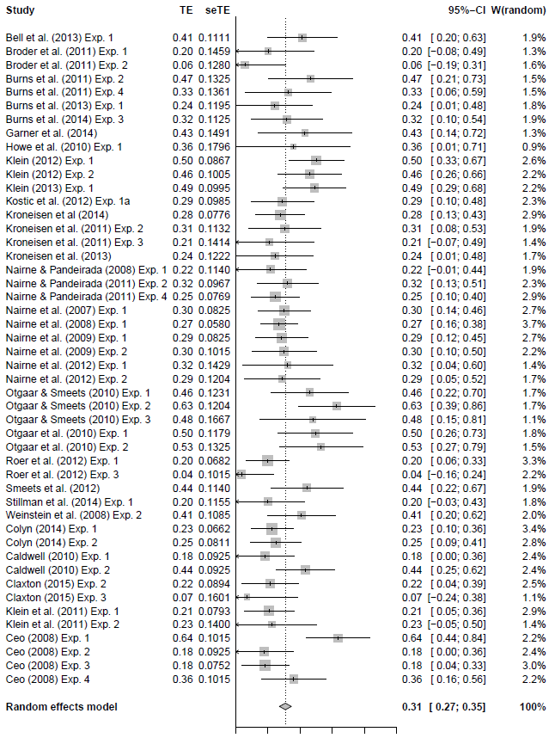

*Figure 1.* This forest plot shows each between-subjects experiment’s author, effect size estimate (listed as TE, with standard error, seTE) with boxes according to each experiment’s weight and horizontal lines depicting confidence intervals. W corresponds to the percent weight for each experiment. It is important to note that these estimates are presented in Fisher’s *z* scale, and can be converted to partial eta squared using equation 8.

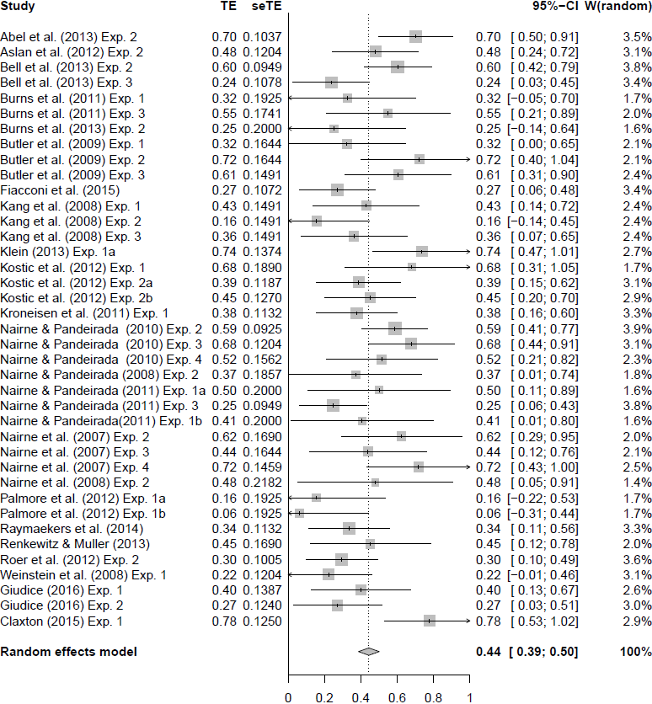

*Figure 2.* This forest plot shows each within-subjects experiment’s author, effect size estimate (listed as TE, with standard error, seTE) with boxes according to each experiment’s weight and horizontal lines depicting confidence intervals. W corresponds to the percent weight for each experiment. It is important to note that these estimates are presented in Fisher’s *z* scale, and can be converted to partial eta squared using equation 8.

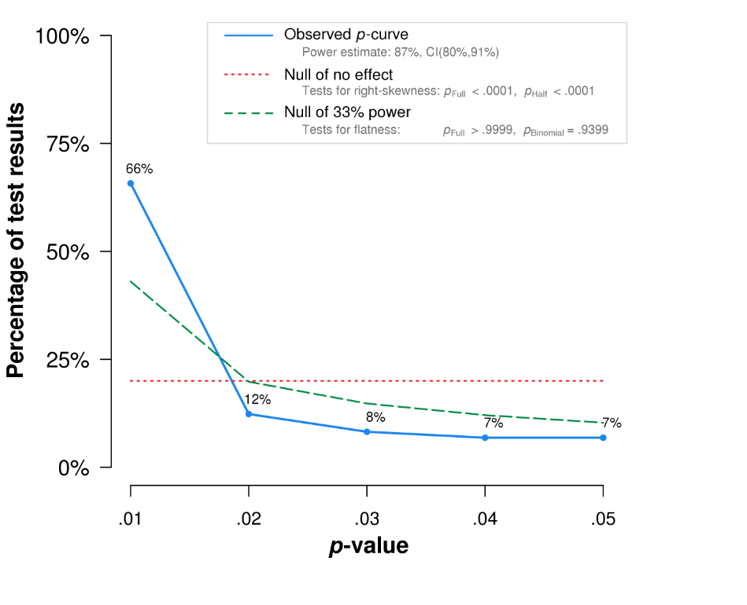

*Figure 3.* This graph depicts the observed *p*-curve for all experiments compared to a uniform distribution and a 33% power distribution. The observed *p*-curve includes 73 statistically significant (*p* < .05) results, of which 57 are *p* < .025. There were 14 additional results entered but excluded from p-curve because they were *p* > .05.

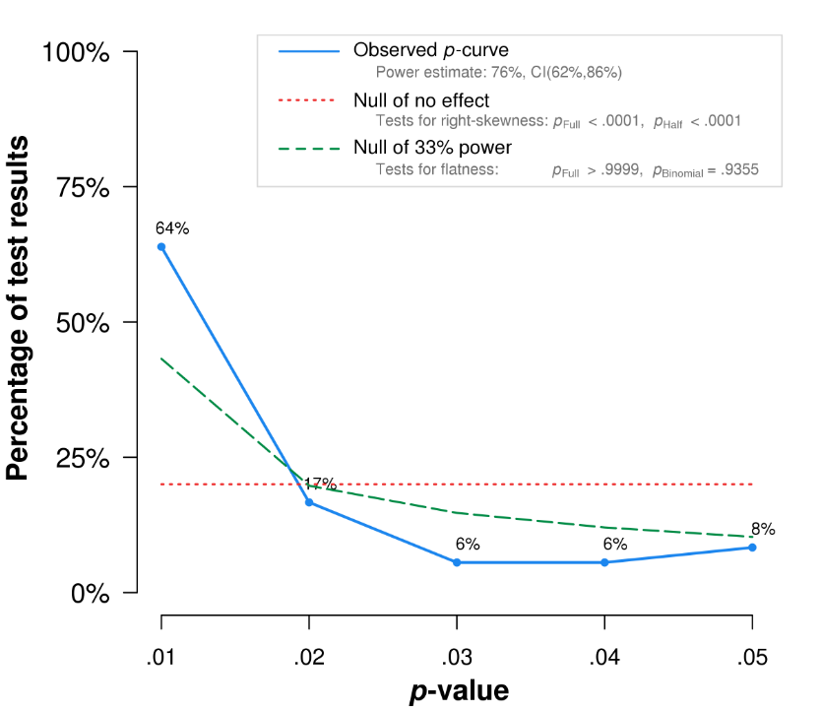

*Figure 4.* This graph shows the observed *p*-curve for the between-subjects experiments subgroup compared to a uniform distribution and a 33% power distribution. The observed *p*-curve includes 36 statistically significant (*p* < .05) results, of which 29 are *p* < .025. There were 12 additional results entered but excluded from p-curve because they were *p* > .05.

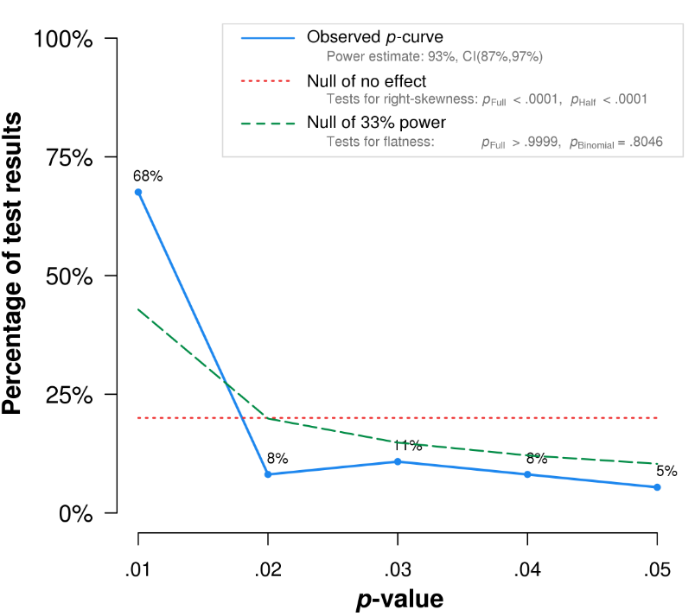

*Figure 5.* This graph shows the observed p-curve for the within-subjects experiments subgroup compared to a uniform distribution and a 33% power distribution. The observed p-curve includes 37 statistically significant (*p* < .05) results, of which 28 are *p* < .025. There were 2 additional results entered but excluded from p-curve because they were *p* > .05.

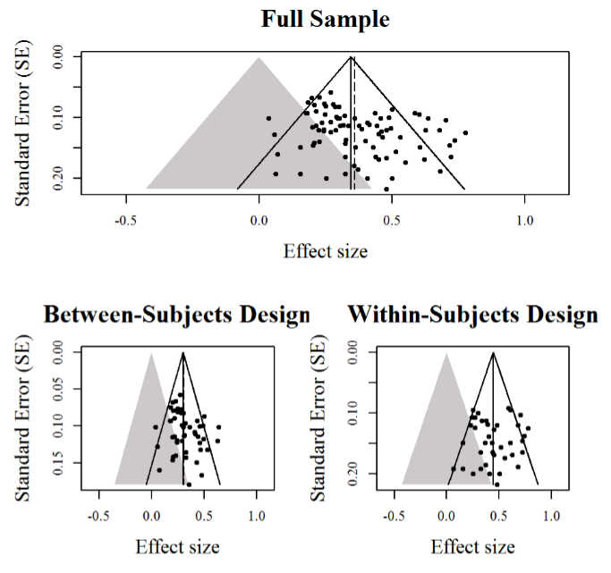

*Figure 6.* These funnel plots show effect sizes along the x-axes and their corresponding standard error along the y-axes for all experiments as well as the two research designs. Funnel plot asymmetry is noted by a lower frequency of data points in the lower center of the plot. The gray area indicates a region of non-statistical significance.

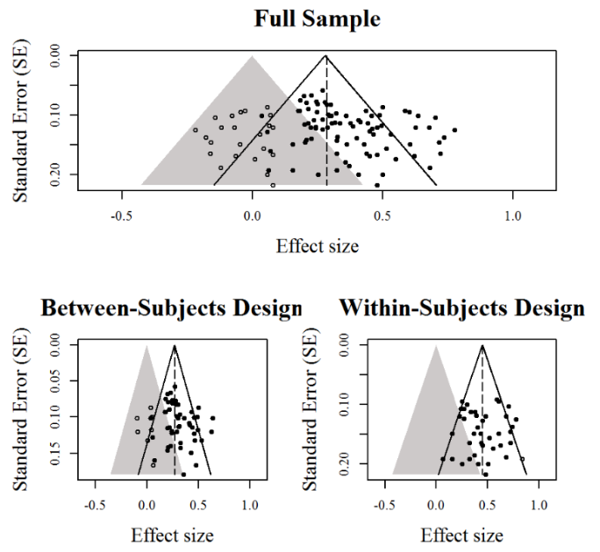

*Figure 7.* These funnel plots show effect sizes along the x-axes and their corresponding standard error along the y-axes for all experiments as well as the two research designs. These three funnel plots depicted post trim and fill analysis after plots have been trimmed and subsequently imputed. Hollow data points indicate experiments that have been “filled in” or added.

1. Alternatively, meta-analyses can also be performed converting all partial eta squared values into Cohen’s *d* values.